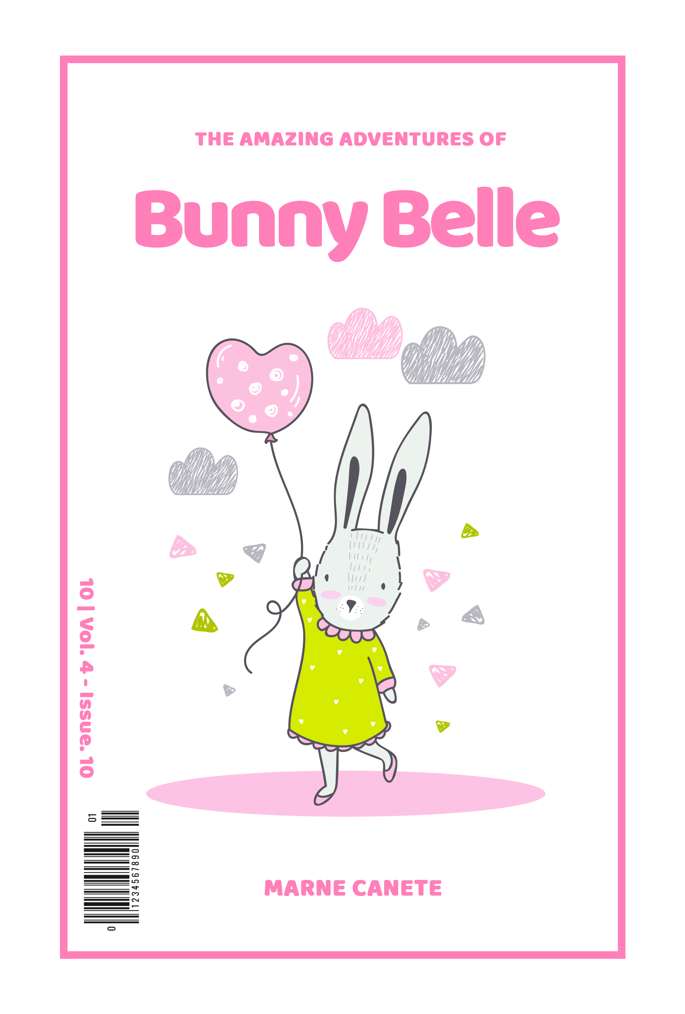

HADITHI ZA ALPHABETI
2022
NA: +255766263437
WILLIAM.W.KAHINDI

MSANIFU WA MICHORO-Zephilin John (ZEJO).
Mchoraji-Kelvin William Kahindi.

UTANGULIZI
Kitabu hiki kina walenga watoto wa shule za msingi waliosoma katika madarasa i,ii,iii na iv.
Madhumuni yake ni walengwa kufahamu herufi mbalimbali zinazotumika katika lugha ya Kiswahili,kuongeza misamiati ya maneno ,kukuza stadi za kusoma ,kuandika, kuzungumza , kutafsiri picha zilizomo kitabuni na kuburudika na hadithi fupifupi zilizomo.

- UTANGULIZI
YALIYOMO
- ANGA……………………………………………………………………………….....1-6
- BAKULI……………………………………………………………………………….7-9
- CHUMVI…………………………………………………………………………….10-11
- DAWA……………………………………………………………………………….12-13
- EMBE…………………………………………………………………………………...14
- FENESI……………………………………………………………………………….…15
- GAZETI…………………………………………………………………………………16
- HEMA…………………………………………………………………….......................17
- INJINI…………………………………………………………………………………....18
- JIKO………………………………………………………………………………….19-20
- KUKU………………………………………………………………………………..21-22
- LAMBO………………………………………………………………………………….23
- MUA……………………………………………………………………………………..24
- NONDO………………………………………………………………………………….25
- OTESHA…………………………………………………………………………….…..26
- PAPAI……………………………………………………………………………….…..27
- QUEEN………………………………………………………………………………….28
- REDIO…………………………………………………………………………………..29
- SOKO………………………………………………………………………………...….30
- TENGA………………………………………………………………………………..…31
- UPELE…………………………………………………………………………………...32
- VIMBA……………………………………………………………………………….33-34
- WAZIRI………………………………………………………………………………….35
- XUMA…………………………………………………………………………………...36
- YAI………………………………………………………………………………………37
- ZEGE…………………………………………………………………………………….38

